DOKUZ EYLUL UNIVERSITY
ENGINEERING FACULTY
DEPARTMENT OF COMPUTER ENGINEERING

CME1251 PROJECT BASED LEARNING – I
FINAL REPORT
PROJECT – I

SHAPER

by
Ahmetcan Temel
Kerem Kalıntaş
Baha Aydoğan
Boran Bereketli

Lecturers
Fatih Dicle
Mehmet Hilal Ozcanhan

IZMIR
23.03.2023

CHAPTER ONE
PROGRESS DESCRIPTION
Discussing and designing solution alternatives.
Creating the necessary variables, structures. Screen.
Class designs. Attributes/methods.
Add and list commands for rooms.
Add and list commands for employee/customer/reservation. Delete command for the employee.
Search, Statistics, Simulation.
Remaining parts of the application.
Testing/Debugging.

CHAPTER TWO
TASK SUMMARY

Completed Tasks
Ahmetcan Temel
I wrote a code that can read a text file and save the informations in the txt file to the classes. I also added our code exit function. I harmonized my read a text file class and my friend code classes.I made a powerpoint for presentation and I also made a Final Report.

Kerem Kalıntaş
I created Hotel, Date, Customer, Address, Main classes. I did the statistics, simulation list commands. I wrote the code for reading commands from the console. I wrote comments and function documentations to the code. I created a git repository to share and track our progress. I rewrited the statistics command because it doesnt work as it should. I tried to create colored printing on the some fields of the classes. And i tried to make the code better by removing unused parts.

Boran Bereketli
I did the deleteEmployee and searchCustomer commands.I made the Reservation class and helped other classes.Tested the code. I made the 'searchRoom' command.The searchRoom, simulation and statistis commands made. Some additional improvements that think added.

Baha Aydoğan
Initialized and added some attributes of some classes and dealt with customer class and array. 'searchRoom' command. I made the poster.

Incomplete Tasks: Reasons and Explanations
Ahmetcan Temel
None.

Kerem Kalıntaş
None.

Baha Aydoğan
None.

Boran Bereketli
None.

Additional Improvements to the Project
Ahmetcan Temel
None.

Boran Bereketli
None.

Kerem Kalıntaş
I removed the limitation of only using year 2024. Code now works in any year.

Baha Aydoğan
None.

CHAPTER THREE
EXPLANATION of algorıthms

Screenshots
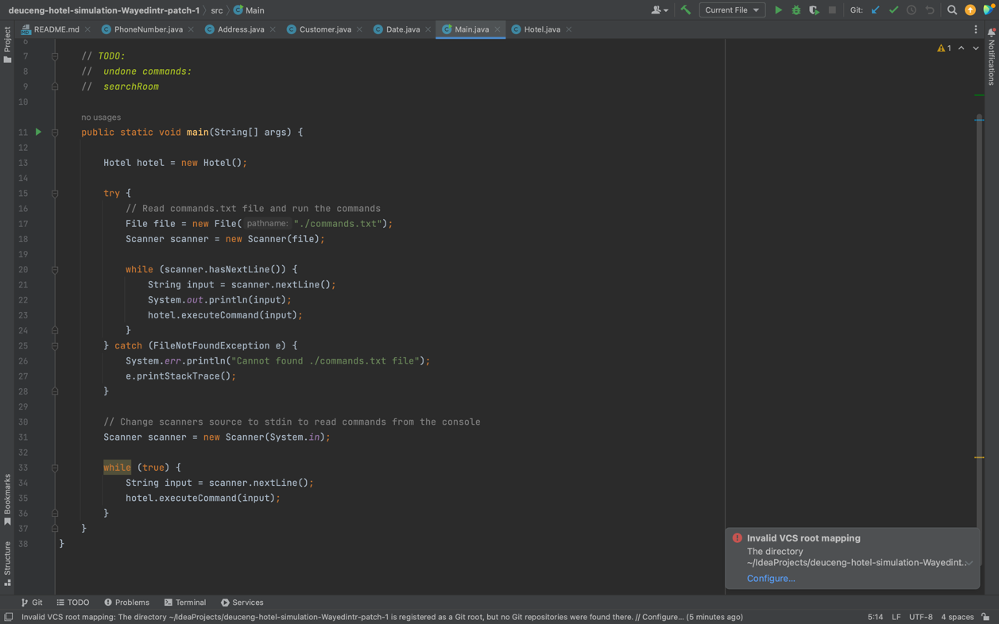

We are getting the commands from the commands.txt file after that we are executing the commands according to commands.txt file. For example, If the commands is AddRoom, We are going to the class that have addRoom function after that we runned addRoom function and we added a room to the Hotel System.
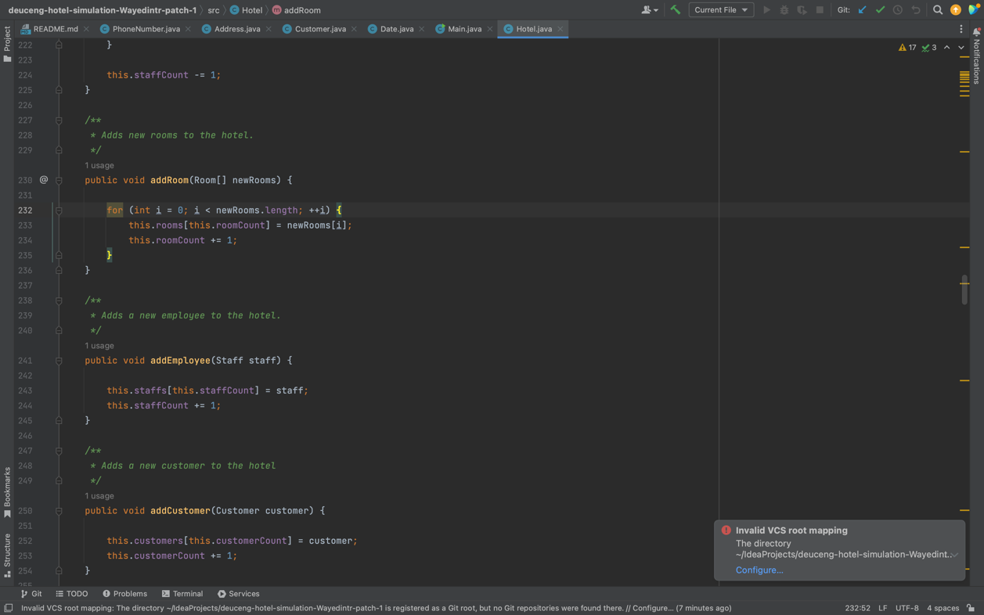

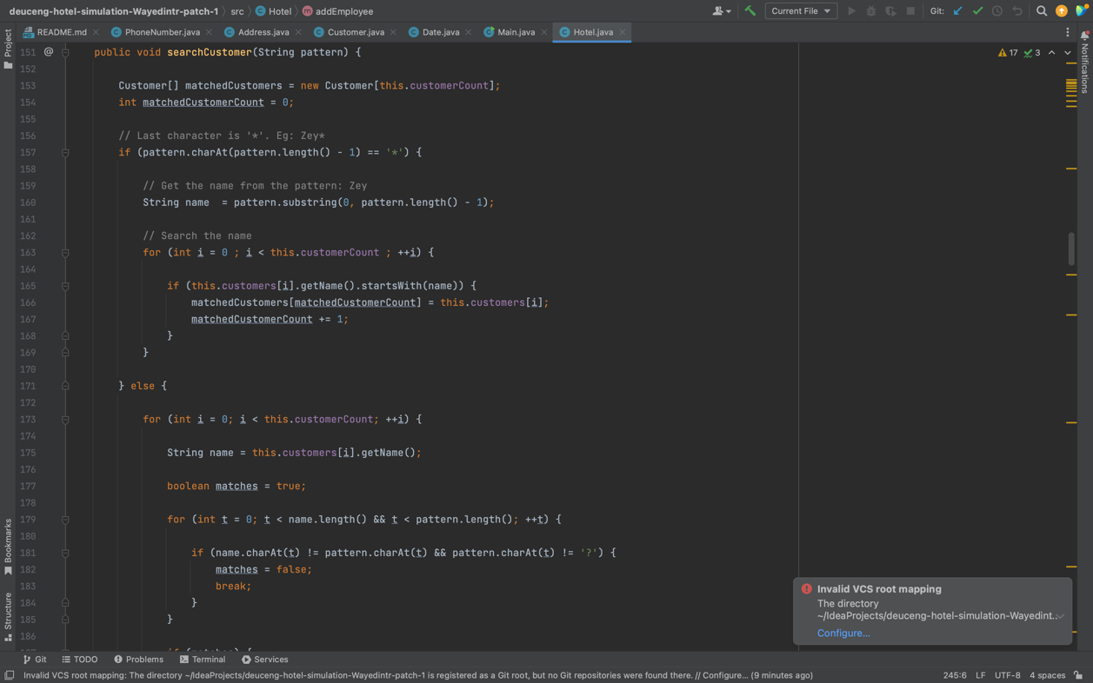

In the search operation Algortihm, the program will find and print the customer names that correspond to a given pattern. The pattern can contain only one star (*) symbol, or one-or-more question mark (?) symbol, but not both of them. For example: Zey* or Zey???.

Functions
- ExecuteCommand (This function executes commands from the commands.txt file and the command line)
- DeleteEmployee (This function deletes employees from Hotel System.)
- AddRoom (This function addes rooms to the the Hotel system.)
- AddReservation(This function adds reservations to the Hotel system.)
- SearchCustomer
- ListCustomer
- ListRooms
- ListReservation

Algorithms and Solution Strategies and Problems Encountered
1) We couldn’t add the all commands to 2D string array while we are reading the file.
Solution Algortihm: We decided to read file line by line and we execute the our code each line.
2) We couldn’t change the phone number to string.
Solution Algorithm: We decided to write our toString method to change the phone numbers to string.
3) We had a hard time calculating the dates while we making the reservations.
Solution Algorithm: We decided to make a class for date information and we wrote a lot of methods to calculate the right date.
4) In the beginning of the project, We couldn't combine our codes properly.
Solution Algorithm: We opened a repository in GitHub and we saw how the code change over time.

conclusıon
With this project, we learned how to create a class in java language, how to write methods in it and how to work with object oriented languages. We also improved our team work abilities in this project.

REFERENCES
https://www.javatpoint.com/
https://www.w3schools.com/java/
https://www.geeksforgeeks.org/java/

AppendIx A
Poster/Web page of the Project
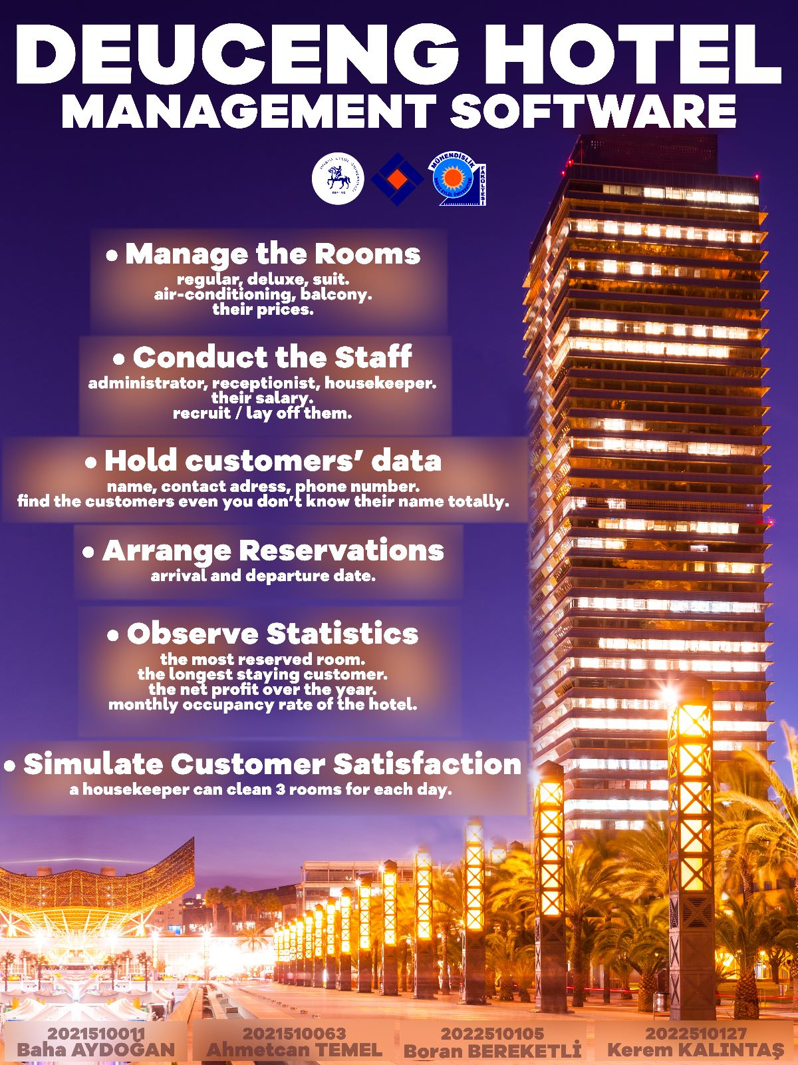

AppendIx B
Code of the
Project

TeamWork Evıdence
